Dear Hilti Engineering Support Team.
I have purchased a Titan 9000 lb 2 post car lift and looking for some recommendations on anchoring it to a concrete floor.

Question:
The position of the lift will have the inside 2 bolts in 3 ½ inch concrete and back 3 in the 7 inches of concrete. Based on Titan’s requirements can I substitute there wedge type anchors with your ¾ inch threaded rod with HY200R V3 adhesive and still meet there requirements.
Based on the design of the lift I feel that the max of 9000 lbs of a vehicle is placing the back three anchors in tension and front 2 in compression. If the back 3 were to start failing then the front two would be in tension also. I have asked Titan for additional information other what is supplied in their installation instructions.

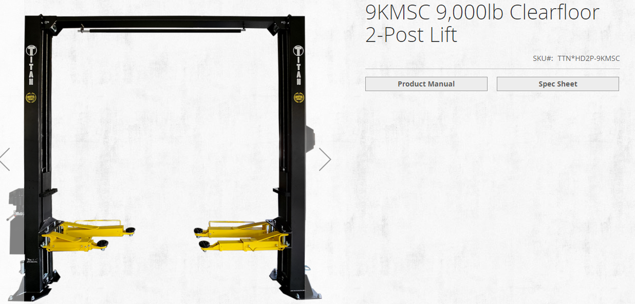

Based on their installation instructions they require a min of 3 ¼ embedment in uncracked 3000 psi concrete using a ¾ inch threaded wedge anchor.
They recommend 4 inches of 3000 psi concrete and drill thru concrete and use there ¾ in wedge type anchor.

Bakke Shop
- 5 inches of 3000 psi concrete
In floor heat using ½ tubing
Effective concrete depth of 4 ½ inches but feel I would only drill down to 3 ½ inches.
- 7 inches of concrete at selected areas (2 ft x 2 ft)

Anchoring Systems
For the 4 1/2 inches of concrete:
Using a HAS ¾ inch threaded rod with HY200V3 and an embedment of 3 ½ inches it has a tension load of 5595 lbs.
Using a Kwik ¾ inch expansion anchor with an embedment of 3 ¼ inches has a tension load of 5630 lbs and with an embedment of 4 ¾ in tension load is 8845 lbs. Using an embedment of 3 ¾ the tension load is 6980 lbs.
For 7 inches of concrete:
Using a HAS ¾ inch threaded rod with HY200V3 and an embedment of 6 ¾ inches it has a tension load of 14986 lbs.
Using a Kwik ¾ inch expansion anchor with an embedment of 4 ¾ inches has a tension load of 8845 lbs. It would be higher using a longer expansion anchor and drilling the hole deeper.

References:
From the Titan 9KMSC 9000 lb Clear Floor 2 Post Lift Installation Instructions.

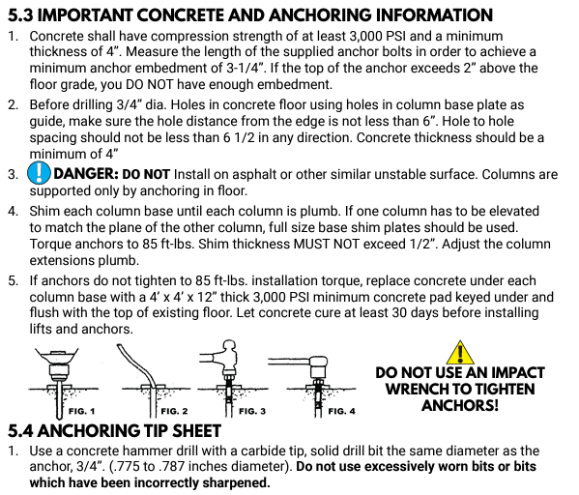

Uses (10) ¾ inch wedge type anchors. Five per post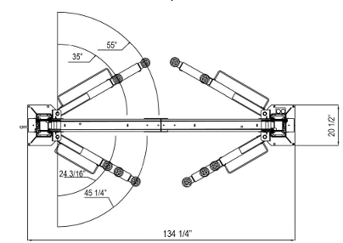 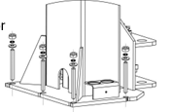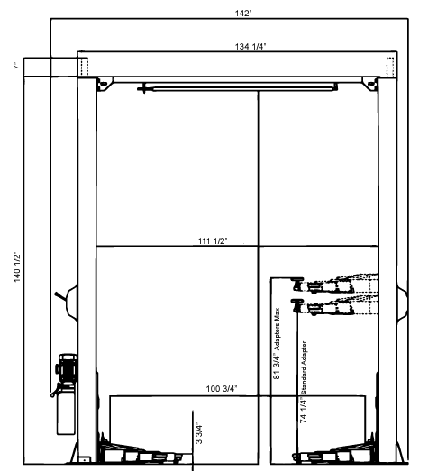

HILTI ¾ in HAS Threaded Rod
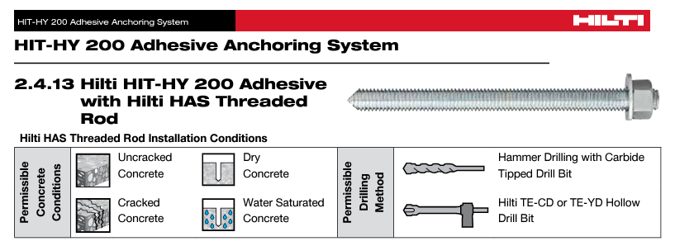

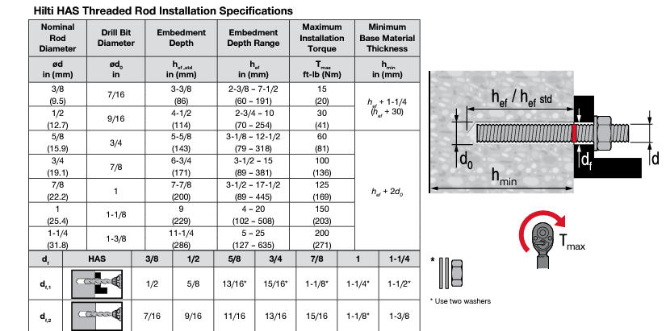

Minimum Concrete Thickness for ¾ in Threaded Rod
Embedment depth – 3.5 inches
Drill Hole Size – 0.875 inches
3.5 + 2(.875) = 5.25 inches

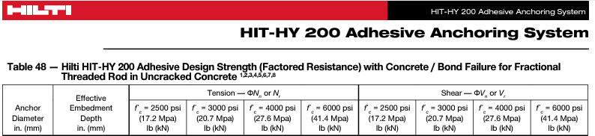
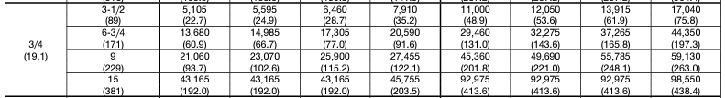

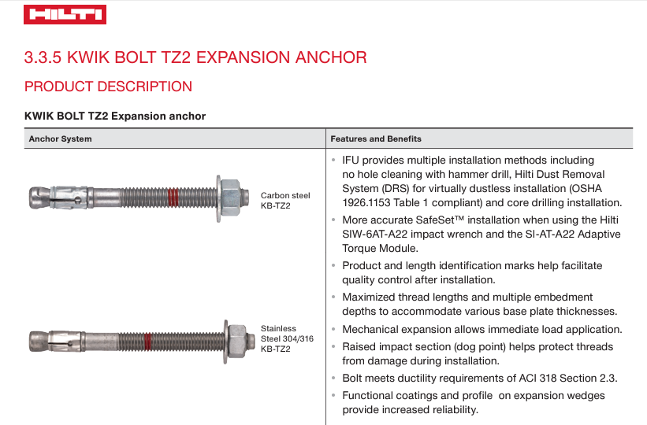
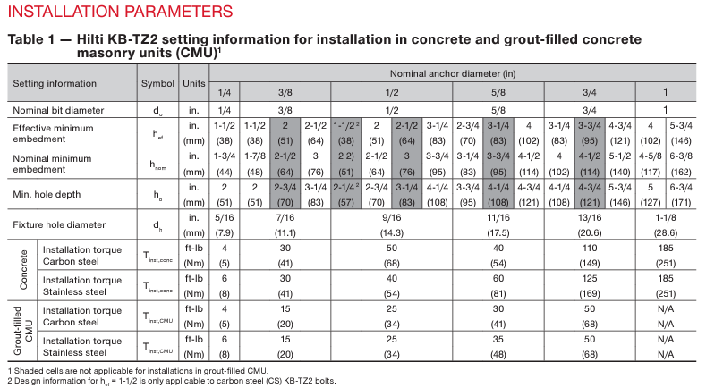
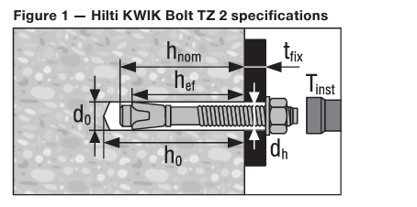

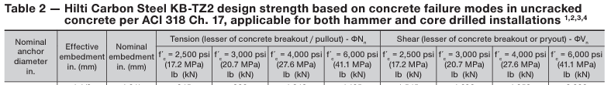
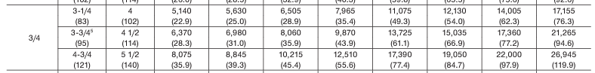

Thank You,
Dan Bakke
920-889-4342

