How to Create a Detailed Report within PROFIS Engineering

- Click “Create Report” in the top right hand corner, then expand the “Layout” tab

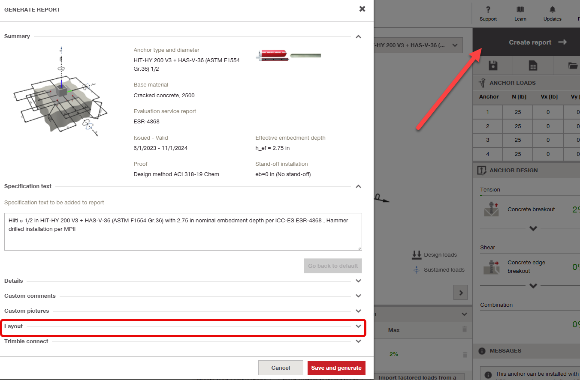

- Within the “Layout” tab, set the Template setting to “Custom” and Report type to “Detailed”

