To request or retrieve Engineering Judgments (EJs) on the Hilti Construction Platform (HCP), you will need to register for a Hilti account which takes just a few minutes.

- Click here or go to https://constructionplatform.hilti.com/, then select “REGISTER”.

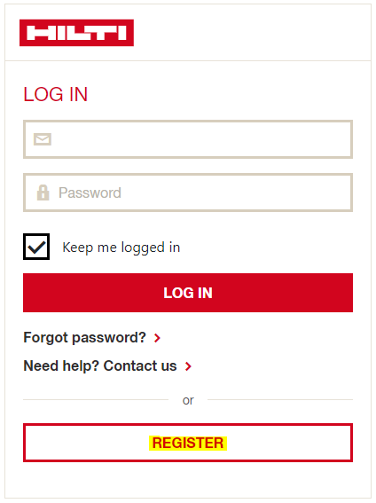

- Register with your company email address and select a password – this same email address is what you will use to login the Hilti Construction Platform.

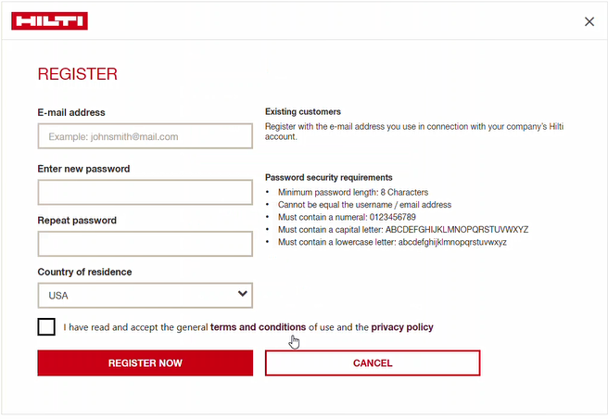

- An email will be sent to your inbox. Click “ACTIVATE ACCOUNT AND PROCEED”.

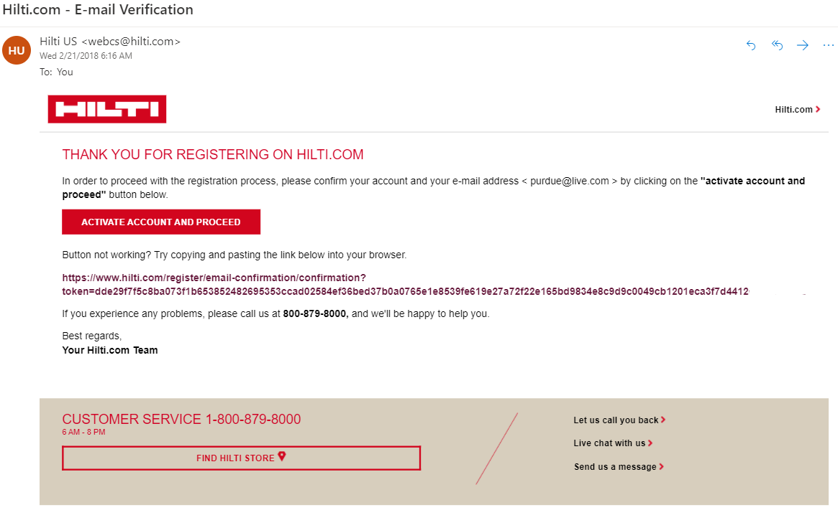

- Congratulations! You are now registered. Click “GO TO LOG IN”

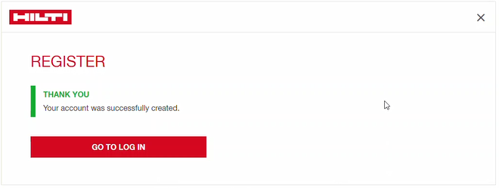

- Welcome to the Hilti Construction Platform! Follow the next for steps to create settings, accept the End User License Agreement (EULA) and Privacy Policy, and Cookies.

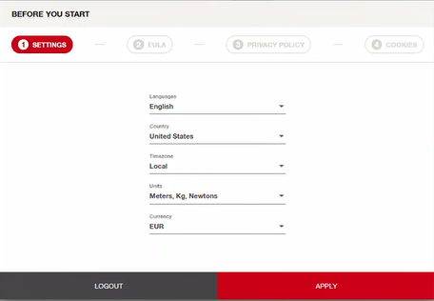

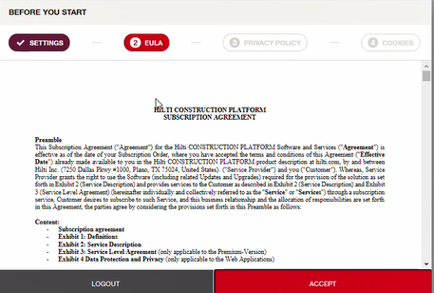

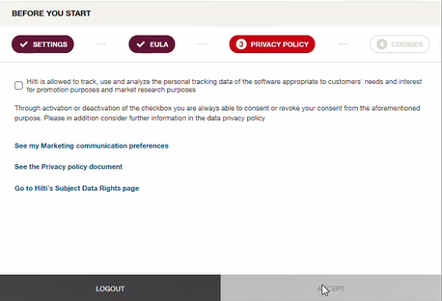

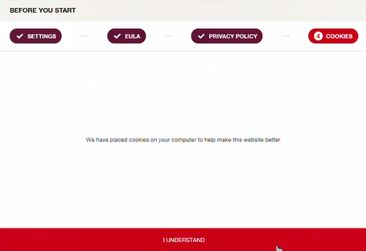

- Congratulations! You may now begin using the Hilti Construction Platform. To learn more, US users may visit here or https://www.hilti.com/ej, and Canada users may visit here or https://www.hilti.ca/ej

For any account registration issues, please contact Hilti Customer Service at 1 (800) 879-8000 (US) or 1-800-363-4458 (Canada).

