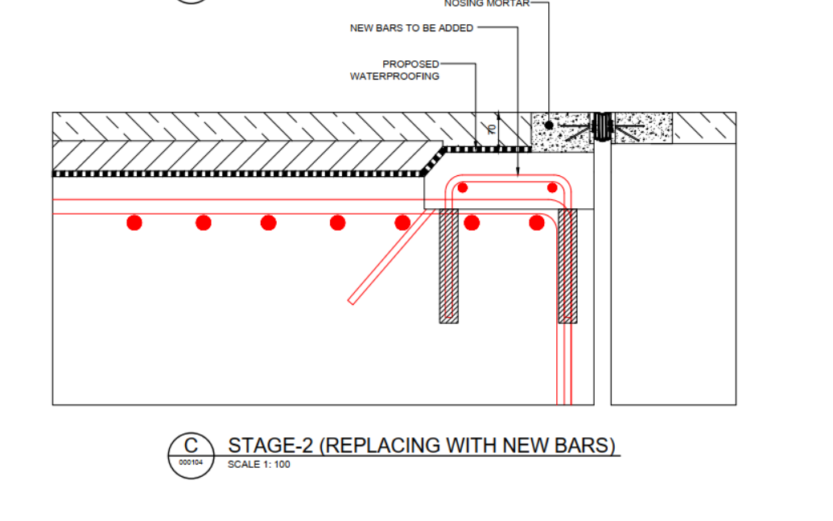
Carriageway with live load
Resin fixed bars
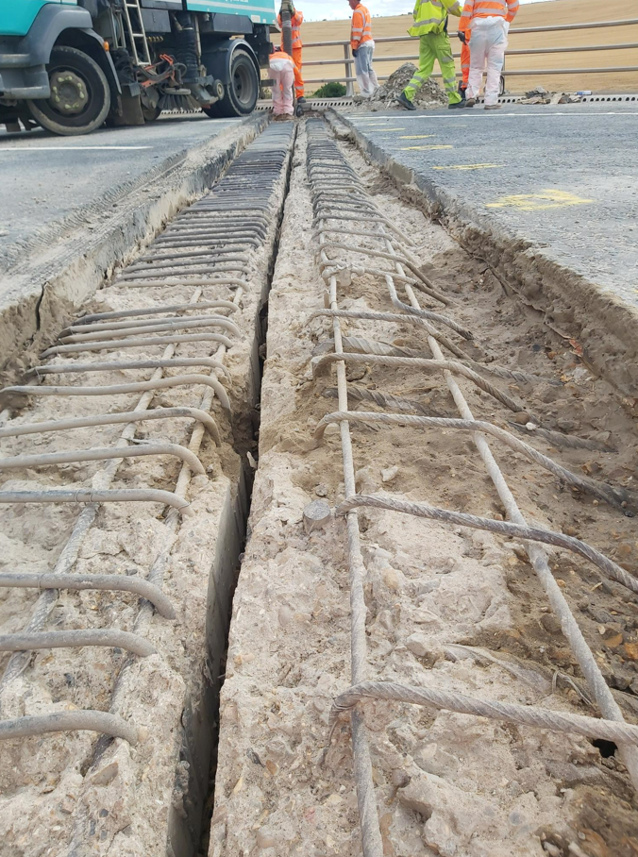
Links to be replaced with the new U bars fixed with resin as shown above

